**Graded Project**

**Problem Statement:**

A Pharmacy shop who has millions of customers are in need of creating a website for their products. As they have hundreds of offline orders coming in every day and it is becoming difficult to keep track of it, your organization has taken up the project. The pharmacy also has tie up with various Diagnostic centers where the pharmacy will take samples from the patients at their doorstep and analyses in the lab. The report will be sent via mail and a hard copy if requested. And your team has asked you to develop a Homepage for the products and the Lab Test form. The requirements of Homepage are as follows.

1. Create a Header (“Pharmacy”) and Footer(“@copyright. Only for demonstration purposes”). Make Sure you align them to the center of the screen.
2. Create a Horizontal Navigation Bar after Header with required tags to link. When hovering on any of the links, make sure the background color changes accordingly. The tag names are as Follows.
   1. Home
   2. Our Medicines
      1. When Hovered on this, show a dropdown list of links for Fever, Muscle Pains, (Cold & Cough)
   3. Health Care
      1. When Hovered on this, show a dropdown list of links for Baby Care, Skin Care, Home Care, Personal Care and Pet Care
   4. Lab Test
      1. When Clicked on Lab Test, Open a form to book the slot.
   5. When the web page is scrolled, make sure that the navigation bar is still seen on the top of the web page.

(Look at the below images for your reference.)

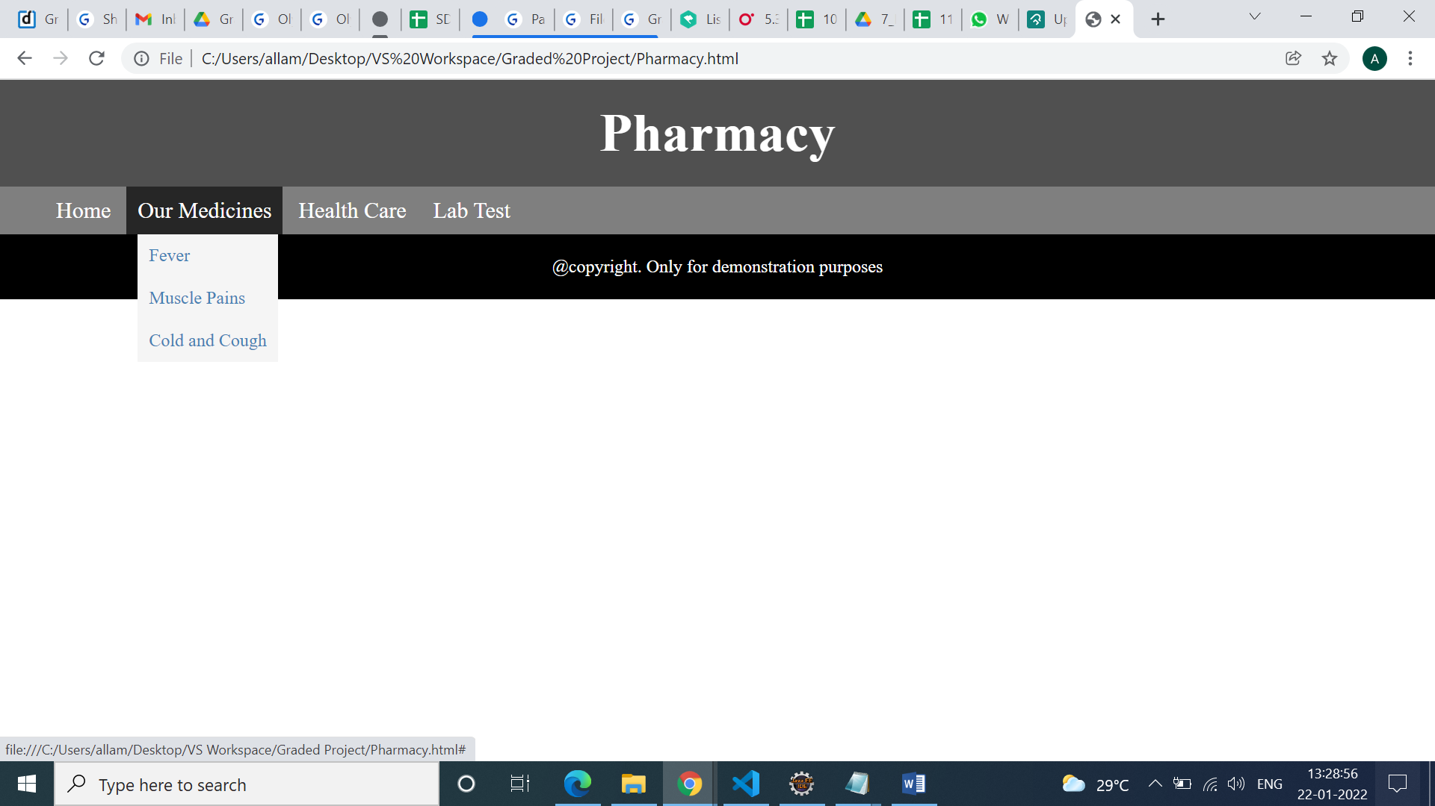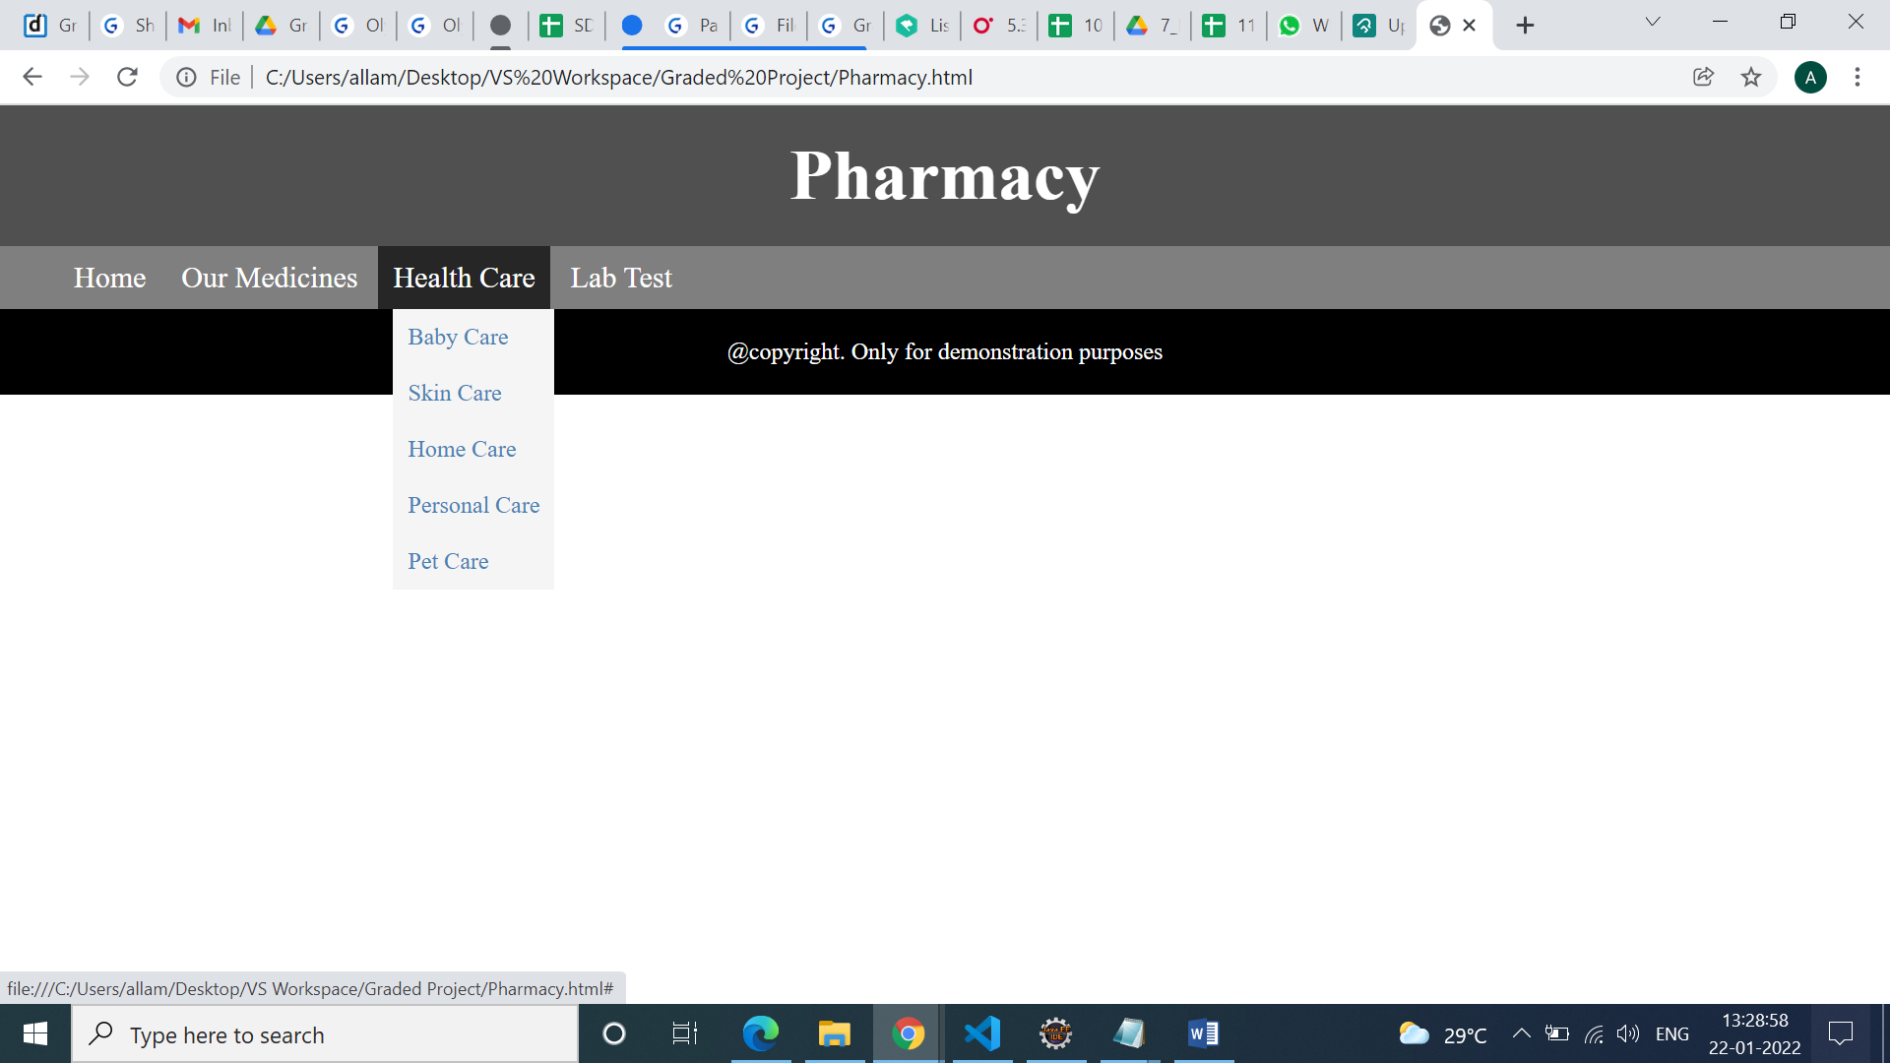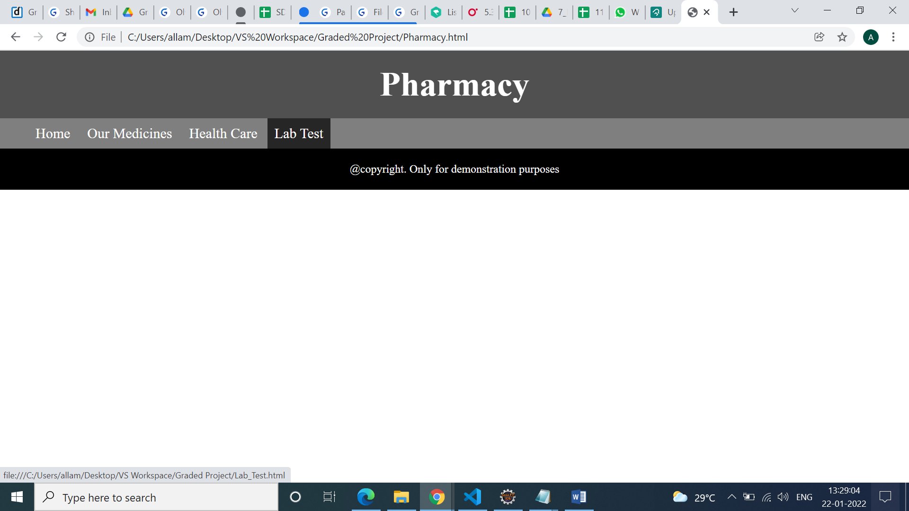

1. First thing in the web page is to show offers or some information in the form of images.
   1. Use the Images given in the project file and create a simple animation to show them one after the other infinite times. Apply a border of 2px solid steelblue.

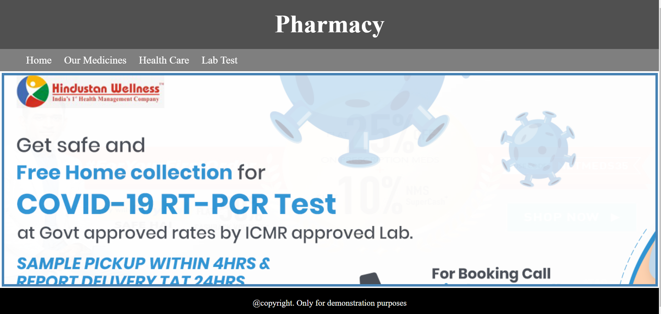

1. Next, In the same page after animation create two sample sections of the products as Covid Care and Diabetes Care.
2. Under Each of them display products with product name, image, Price and Price after Offer and a Add to Cart option. When clicked on the button, the background color should change to rgb(250, 234, 230) and the border should change to rgb(0, 255, 76). When hovered on each product, slightly increase the width and height of it. Make Sure the output looks as shown below.

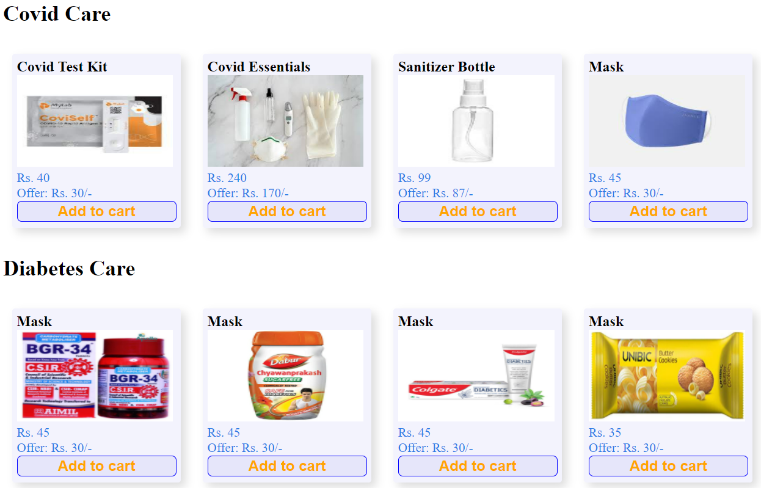

1. When clicked on Lab Test in the Navigation bar, a form shall open with validation in a new page with following details.
   1. Form shall have Patient Contact Details as follows.
      1. Full Name
      2. Patient Id if exists
      3. Contact Number
      4. Email Id
   2. Address
      1. House Number
      2. Street
      3. Area
      4. District (List. Make Sure first option is “Choose”)
   3. Choose the Test Type. Show a message (Check atleast one box without fail)
      1. CBC
      2. Complete Urine
      3. Lipid Profile
      4. Thyroid Stimulating Hormone(TSH)
      5. Glucose Test
   4. Do you want a hard copy of the report also?
      1. Yes
      2. No
   5. Select Your Comfortable Date and Time
      1. Date
      2. Time
   6. Reset and Submit button
2. On the Right Side of the form insert an image which will not move when you scroll the page. Make Sure Your form looks as below.  
   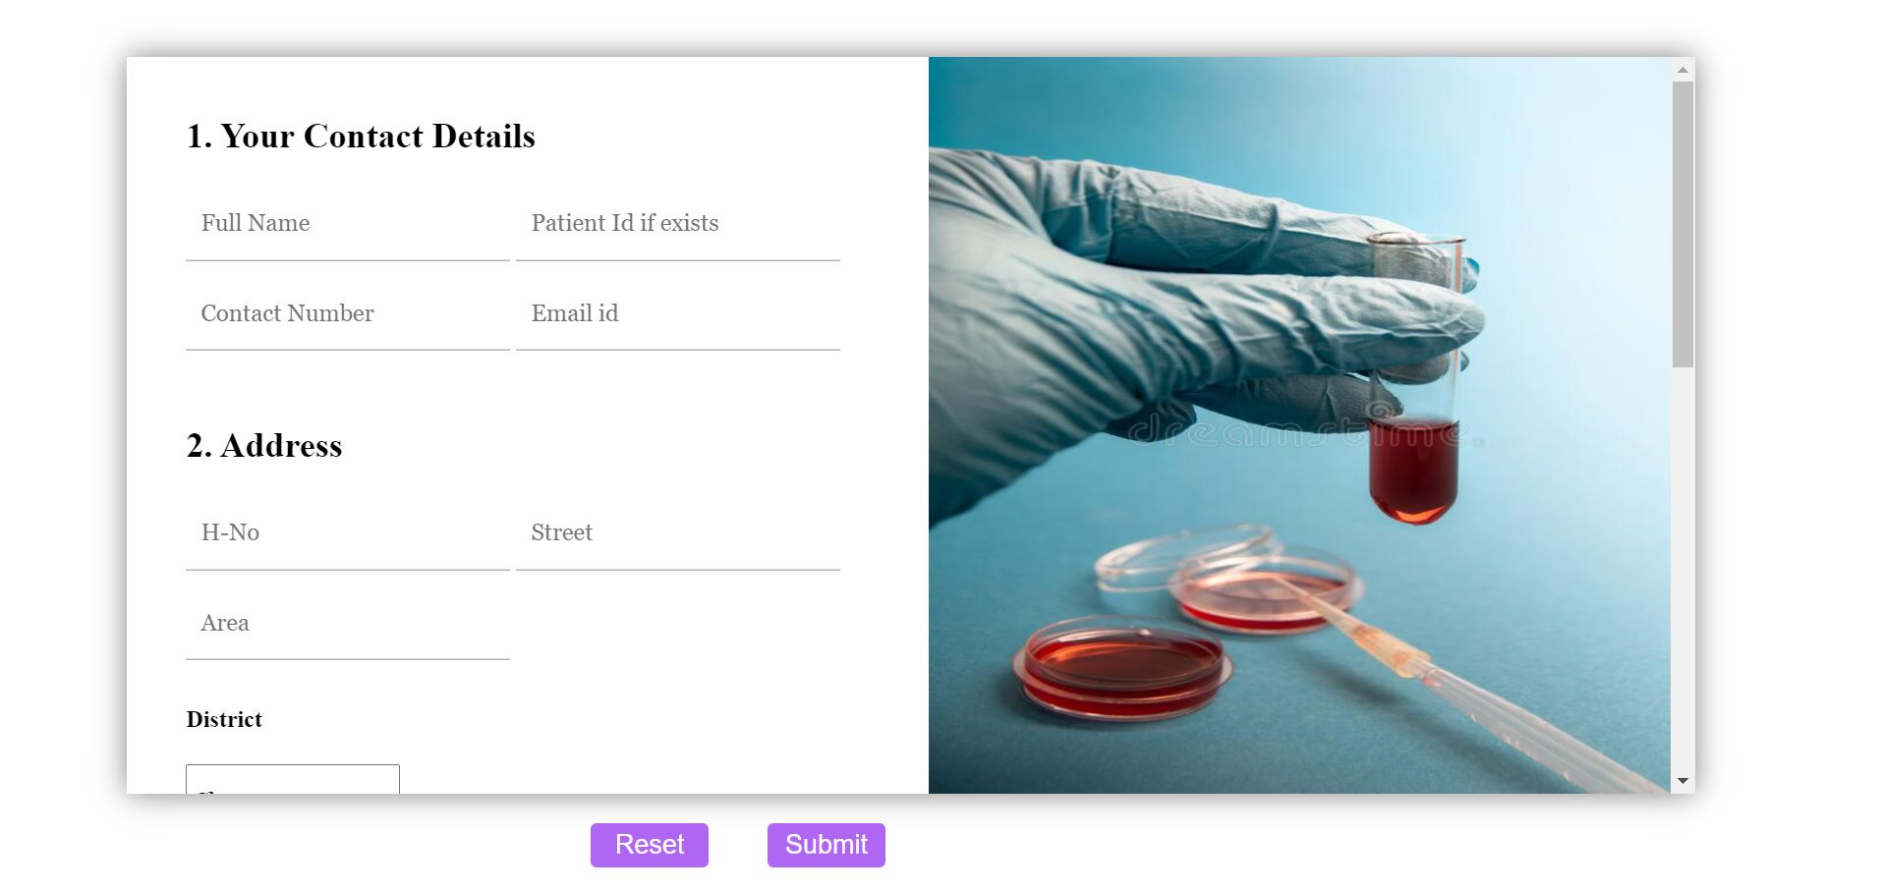

**General Instructions:**

1. Make sure you create a responsive form or web page (when the browser is resized your form pr web page should behave accordingly).
2. Provide padding, margins, page titles, page names where needed.
3. Write all your css code in a .css file.
4. Upload all your files along with images. Make sure images are well sorted.
5. Name the files appropriately.
6. Do not upload zip/compressed files
7. **Make sure all the links/url are provided according to the project structure keeping in mind for github and not related to the local machine.**